Chapter 6, Problem 17.

Determine the equivalent capacitance for each of the circuits in Fig. 6.51.

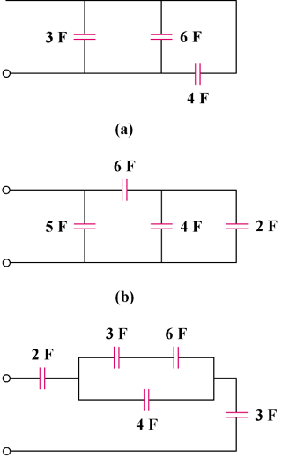

Figure 6.51
For Prob. 6.17.

